**Amazon Cognito**

Amazon Cognito is an Amazon Web Services (AWS) product that controls user authentication and access for mobile applications on internet-connected devices. The service saves and synchronizes end-user data, which enables an application developer to focus on writing code instead of building and managing the back-end infrastructure. This can accelerate the mobile application development process.

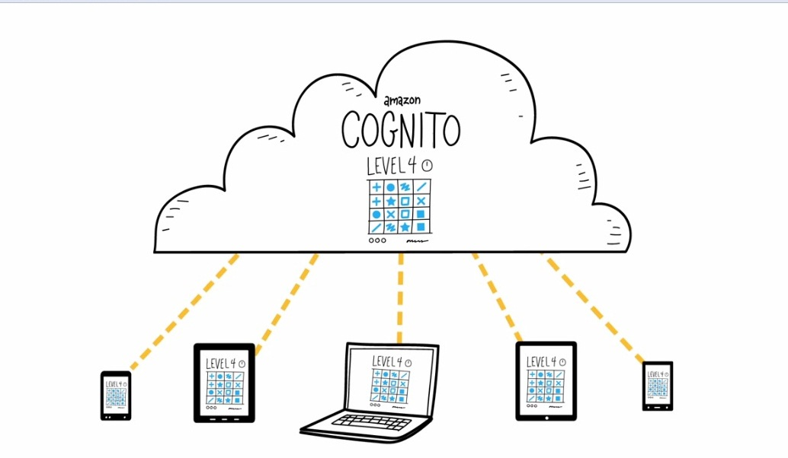

Amazon Cognito collects a user's profile attributes into directories called user pools that a mobile app or web app uses to configure limited access to AWS resources. An identity pool consolidates end-user information, which client access platforms, devices and operating systems receive to organize federated identity groups. Data synchronizes with AWS when a device is online, allowing an end user to access the same information on another device. Data can also be saved locally to a SQLite database while offline before reconnecting. Amazon Cognito associates data sets with identities and saves encrypted information as key or value pairs in the Amazon Cognito sync store. Each user can save a maximum of 20 MB of data, with each individual data set containing up to 1 MB.

**Managing identities**

An administrator can create sign-up and sign-in functionality with Amazon Cognito Identity, which comes with additional security features, such as email or phone verification and multi-factor authentication. An admin can integrate AWS Lambda with Amazon Cognito Identity to add logic for customizable security features

### Supported platforms

A mobile app developer can use a software development kit (SDK) to integrate with Cognito or directly access server-side APIs.

AWS supports Amazon Cognito in its AWS Mobile SDK, which includes libraries, code samples and APIs to help developers use the service. The SDK is available for iOS, Android, Unity and Kindle Fire. The AWS SDK for JavaScript also supports Cognito. User pools are available in the AWS SDK for JavaScript and the AWS Mobile SDK for iOS and Android.